School | Christ Church C.E | Lark Hill | Lewis Street
Data: | Summer 2024 | Summer 2024 | Summer 2024
Review Date: | Summer 2026 | Summer 2026 | Summer 2026

Designated Governor:

Signature:

Aims and objectives
Our policy on school uniform is based on the belief that school uniform:
- promotes a sense of pride in our school;
- helps to create a sense of community and belonging towards the school;
- identifies the children with the school;
- supports our commitment to inclusion;
- prevents children from wearing ‘fashion clothes’ that could be distracting in class;
- is practical, smart and designed with health and safety in mind;
- is considered good value for money by most parents.

Expectations
We expect all pupils to comply with this uniform policy and will be regularly monitored. Where uniform does not meet the agreed requirements, pupils and/or parents/carers will be advised of this accordingly by their class teacher. An agreed timescale will be given for uniform to be rectified. Continued failure to comply will be brought to the attention of the Phase Leader and/or the Head of School.

The Role of Parents/Carers
We believe that one of the responsibilities of parents is to ensure that their child has the correct uniform and PE kit, and that it is clean, in good repair and that the child’s name is written on all items.

The Role of Governors
The governing body supports the Head of School and Executive Headteacher in implementing the School Uniform Policy. It considers all representations from parents/careres regarding the uniform policy and liaises with the Head of School/Executive Headteacher to ensure that the policy is implemented fairly and with sensitivity. It is the governors’ responsibility to ensure that the school uniform meets all regulations concerning equal opportunities. Governors ensure that the school Uniform Policy enables children to dress sensibly, in clothing that is hardwearing, safe and practical

Headscarves/Hijjab
These may be worn for religious reasons but must be in school colours – black; white or green (Christ Church); black; white or purple (Lark Hill) and black; white or navy blue (Lewis Street).

Jewellery
It is not appropriate for children to wear jewellery except a sensible watch and a pair of small plain stud earrings.

Hairstyles
Hairstyles should be appropriate for school, i.e. no “mohicans”, no designs cut into hair, no extremely short hair (no-guard or number 1) or bright coloured highlights. All long hair (shoulder length or longer) should be tied back. Headbands or hair bobbles should be plain black; white or green (Christ Church); black; white or purple (Lark Hill) and black; white or navy blue (Lewis Street).

School Bags
There is no reason for children to bring large bags into school. There is a great shortage of space in the cloakrooms and large bags exacerbate the problem. Children will need a reading book bag. These can be purchased from the school office. Children will need a PE bag which should remain in school. Children on packed lunches should have a packed lunch box, storage for which are provided in school. Children are encouraged to bring a water bottle into school which is clearly labelled with their name.

Equality Impact Assessment
As a school community we are committed to promoting equality. Therefore, an equality impact assessment has been undertaken and we believe this policy is in line with the Equality Act 2010 as it is fair, it does not prioritise or disadvantage any pupil and it helps to promote equality at this school.

Monitoring and Review
The governing body monitors and reviews the school uniform policy through its committee work by: seeking the views of parents/carers, to ensure that they agree with and support the policy; considering, with the Head of School and/or Executive Headteacher, any requests from parents for individual children to have special dispensation with regard to school uniform.

For indivual school uniform details, please see:

Appendix 1 Christ Church CE Primary
Appendix 2 Lark Hill Primary
Appendix 3 Lewis Street Primary

Appendix 3

We have high expectations for uniform at Lewis Street. We pride ourselves on how smart our children look and we thank you for your support in this. Please see below our expectations for uniform.

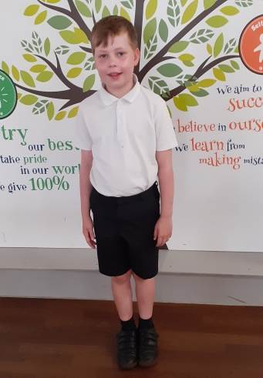

Boys
- Grey or black trousers or shorts
- White polo shirt
- Navy blue jumper or school sweatshirt
- Black shoes or black trainers (no logos or boots)
- Grey or black plain socks

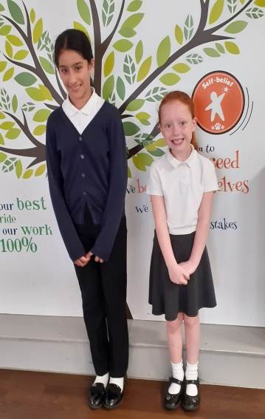  Girls | 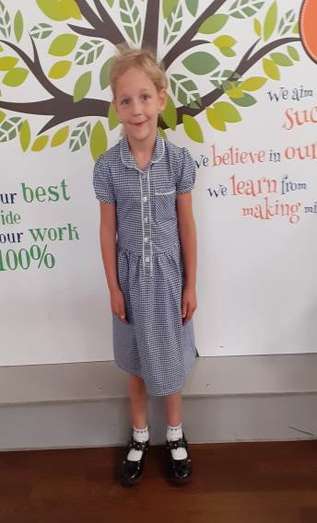
- Grey or black skirt, pinafore or trousers
- White polo shirt
- Navy blue jumper, school sweatshirt or cardigan
- White or grey socks
- Grey or black tights
- Navy blue or black plain hair accessories, hair must be tied up. No large bows, flowers or large hair bands.
- Black shoes or black trainers (no logos or boots)
- Navy and white gingham Summer dress
- Girls are permitted to wear small stud earrings only. Hooped earrings are not permitted.

Shoes | 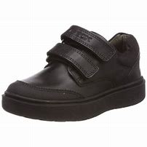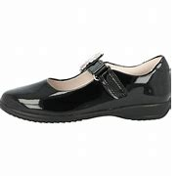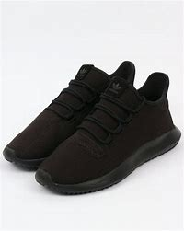
Children are permitted to wear plain black school shoes or trainers.
Trainers must be fully black, no white soles or logos permitted.

PE | 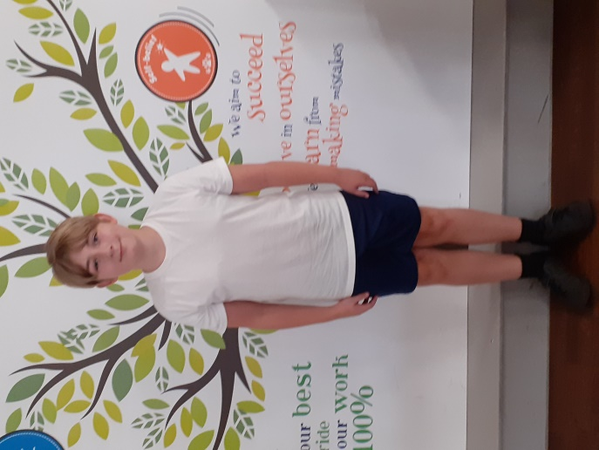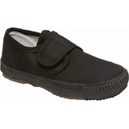
Girls and Boys:
- Plain black/navy shorts or plain black tracksuit bottoms, no logos
- Plain white T-shirt or polo top, no logos or motifs
- Navy blue jumper, school sweatshirt
- Plain black pumps or plain black trainers.

Children who do not have the correct PE kit will be provided with a spare kit to wear.

Book Bags | 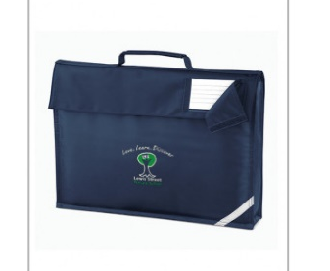
All children need to bring a book bag to school on a daily basis. These can be purchased from Touchline.co.uk.
Children do not need pencil cases as everything is provided by school.
Rucksacks are not permitted in school due to the limited space in cloakrooms.

Please ensure your child’s name is put on all items of clothing. Uniform can be bought from Touchline.co.uk or from any large supermarket. Sports brands are not permitted. You will contacted by your child’s class teacher if your child does not have the correct uniform on in September.
Touchline UK - Shop by School / Lewis Street Primary School (touchline-embroidery.com)

