
Year 4 Long Term Plan 2025/2026 – Lark Hill Community Primary School

Subject | Autumn 1 | Autumn 2 | Spring 1 |  |  | Spring 2 | Summer 1 | Summer 2
 | The Whale  by Ethan and Vita Murrow  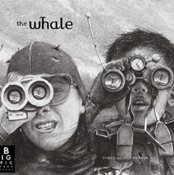  Writing outcome:  Setting Narrative  Newspaper Report | Leaf  By Sandra Dieckmann  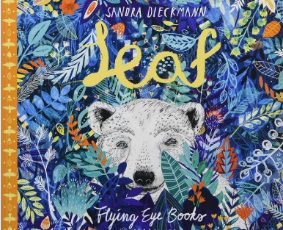  Writing outcome:  Outsider Narrative  Information Report | Arthur and the Golden Rope  By Joe Todd-Stanton  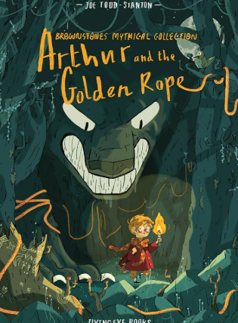  Writing outcome:  Myth Narrative  Information Guide |  |  | The Lost Happy Endings  By Carol Ann Duffy  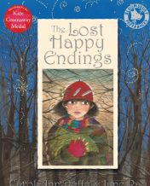  Writing Outcome:  Twisted Narrative  Persuasive Letter | The Journey  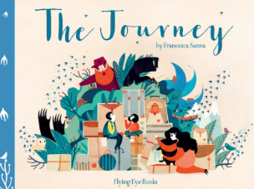  By Francesca Sanna  Writing Outcome:  Refugee Narrative  Diary | Manfish  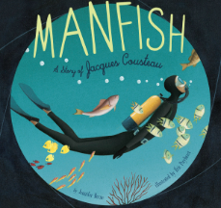  By Jennifer Berne  Writing Outcome:  Invention Narrative  Biography
Maths | Place value  Addition and subtraction | Area  Multiplication and division | Multiplication and division  Length and Perimeter |  | Fractions  Decimals |  | Decimals  Money  Time | Shape  Statistics  Position and Direction
Science | Spiral curriculum
History | How have children’s lives changed? |  | What changed in Britain after the Anglo Saxon invasion? |  |  |  | How did the achievements of the ancient Maya impact their society and beyond?
Geography | Why are rainforests important to us? |  | Where does our food come from? |  |  |  | What are rivers and how are they used?
Art | Elizabeth Catlett (Sculpture) |  | Claude Monet (Painting) |  |  |  | Lucie Bellion (Textiles)
DT | Book Sleeves |  | Playgrounds |  |  |  | Healthy Packed Lunches
RE | Why is the Bible important to Christians? | What can we learn from religions about deciding what is right and wrong? | What does it mean to be a Hindu in Britain today? |  | Why do some people think life is a journey? |  | Why is Jesus inspiring to some people?
PSHE | Being Me in My World | Celebrating Difference | Dreams & Goals | Healthy Me |  |  | Relationships | Changing Me
Spanish | Ourselves | Celebrations | School | Weather |  |  | Hobbies | Holidays
Computing | Coding | Online Safety | Hardware Investigators  Spreadsheets | Writing for different audiences |  |  | Logo | Effective Searching  Animation

