
Year 3 Long Term Plan 2025/2026 – Lark Hill Community Primary School

Subject | Autumn 1 | Autumn 2 | Spring 1 |  |  | Spring 2 | Summer 1 | Summer 2
English | The Iron Man  by Chris Mould  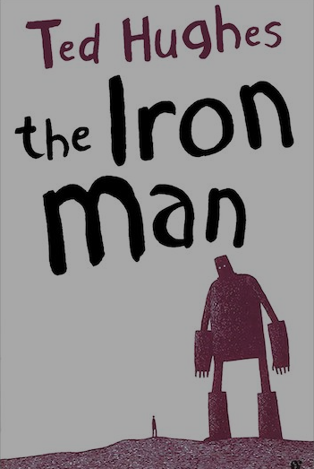  Writing outcome: Narrative – threat  Writing outcome: Non-fiction - Explanation | Fox  By Margaret Wild  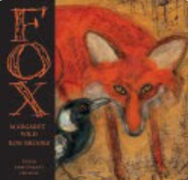  Writing outcome: Narrative – Fable  Writing outcome: Non-fiction – Information Report | The Rhythm of the Rain  By Grahame Baker-Smith  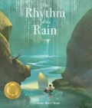  Writing outcome: Narrative – Setting  Writing outcome: Non-fiction – Information Leaflet |  |  | The Visible Sounds  By Yin Jianling  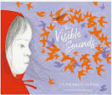  Writing outcome: Narrative – Adventure | Egyptology  by Dugald Steer  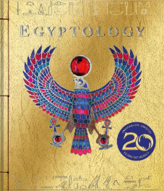  Writing Outcome:  Egyptian mystery narrative.  Secret Diary | Into the Forest  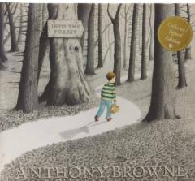  by Anthony Browne  Writing Outcome:  Lost Narrative.  Newspaper report
Maths | Place value (6 weeks) | Addition and subtraction (7 weeks) | Multiplication and division (6 weeks |  | Fractions (5 weeks)  Money (2 weeks) |  | Geometry (3 weeks)  Time (3 weeks) | Statistics (2 weeks)  Length and Perimeter (3 weeks)
Science | Forces and Magnets  Animals |  | Life Cycles  Light and shadow |  |  |  | Plants  Making Connections
History | Stone Age to Iron Age  How much has life changed from the Stone Age? |  | Egyptians  How can we discover what Ancient Egypt was like over 5,000 years ago? |  |  |  | Romans  What impact did the Romans have on life in Britain?  (local study)
Geography | Volcanoes  Why do people live near volcanoes |  | Antarctica  Who lives in Antarctica? |  |  |  | Settlements  Are all settlements the same?
Art | Painting and Mixed Media  Prehistoric Paintings |  | Craft and design  Ancient Egyptian Scrolls |  |  |  | Sculpture and 3D  Abstract Shape and Space
DT | Mechanical systems  Pneumatic toys |  | Textiles  Egyptian collars |  |  |  | Cooking and Nutrition  Seasonal food
RE | What does it mean to be a Christian? | Why do people pray? | Why are festivals important to religious communities? (Easter Focus) |  | How do family life and festivals show what matters to Jewish people? |  | What do people believe about God?
PE | Foundation 92 | Foundation 92 | Foundation 92 |  | Foundation 92 |  | Foundation 92 | Foundation 92
PSHE | Being Me in My World | Celebrating Difference | Dreams & Goals | Healthy Me |  |  | Relationships | Changing Me
Spanish | Greetings with puppets | Numbers and ages | Shapes and Colours | Classroom objects |  |  | Where do you live? | Journey about Latin America
Computing | Touch typing/Email | Coding/Online  safety | Spreadsheets | Branching  databases |  |  | Simulations/  Graphing | Presenting

