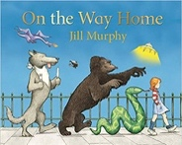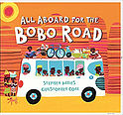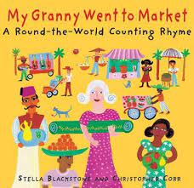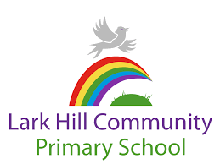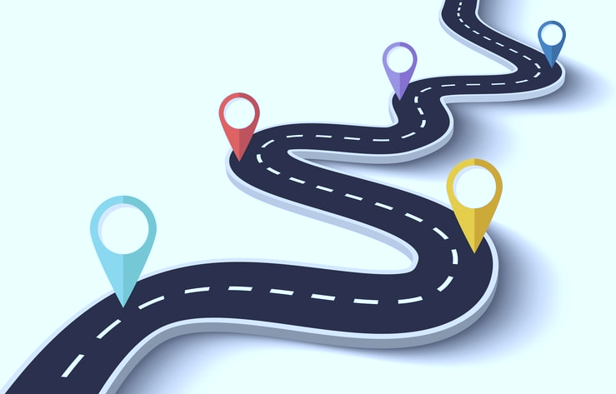



**Through the wider curriculum…**

* Children will learn about journeys and discuss features of their local area as well as features of other countries, making comparisons between the two.
* Children will describe their immediate environment using knowledge from observation, discussion, stories, non-fiction texts and maps
* Know some similarities and differences between different religious and cultural communities in this country, drawing on their experiences and what has been read in class
* Explain some similarities and differences between life in this country and life in other countries, drawing on their own experiences, or their knowledge from books and videos.
* Children will continue to develop their interests around creative arts and design using mixed media to express their interests. They will use appropriate techniques safely and develop their understanding around creating for a purpose using taught sessions and their own imaginations as a stimuli.
* They will also continue to develop their imaginations using song and movement and create their own interpretations of familiar and new texts.
* Talk will be developed through our TALK and P4C sessions using age appropriate game and activities. The children love playing ‘Would you rather’ and ‘Odd one out’.

**In Maths…**

* Children will have a deep understanding of numbers to 10.
* Children will subitise up to 5.
* Automatically recall number bonds up to 5 and some number bonds to 10, including double facts.
* Verbally count beyond 20.
* Compare quantities up to 10 in different contexts, recognising when one quantity is greater than, less than or the same as the other quantity.
* Explore and represent patterns within numbers up to 10, including evens and odds, double facts and how quantities can be distributed equally.
* Children will explore simple patterns with 2D and 3D shapes.

**Are we nearly there yet?**

This half term the children’s imaginations will be taken on a journey to familiar and exciting new places! They will travel in style to space in a cardboard box, go on an exciting bus journey and take a very interesting walk home. Together we will look at our familiar environment and further afield, I wonder where a map and our imaginations will take us. This will lead us onto looking different cultures around the world.and exploring similarities and differences between them. We will use stories to stimulate discussion and encourage children to share their experiences with the class. We cannot wait to go on our adventures…how will we get there?



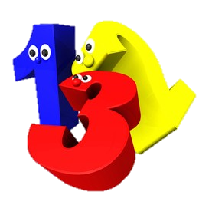

**In Literacy…**

* Children will develop their interests around fiction and non-fiction stories and be able to recall these stories orally and through simple sequencing tasks.
* Children will continue to develop their fluency with reading through daily phonics sessions and within literacy sessions.
* Children will write focussing on oral rehearsal, holding a sentence, finger spaces, capital letters and full stops.
* They will write purposeful sentences around our class text and use their imaginations to create their own ideas around real and imaginary journeys.

Reception Summer 2- Curriculum Overview



