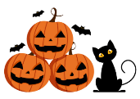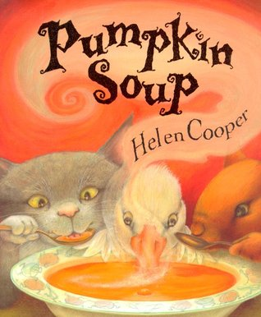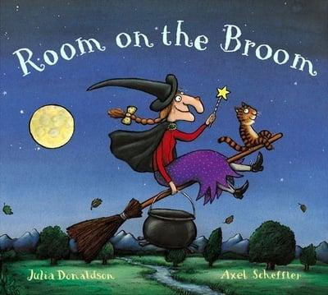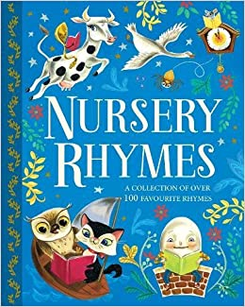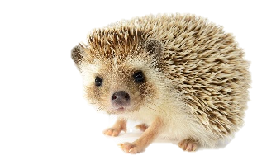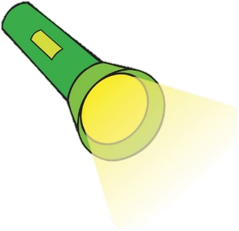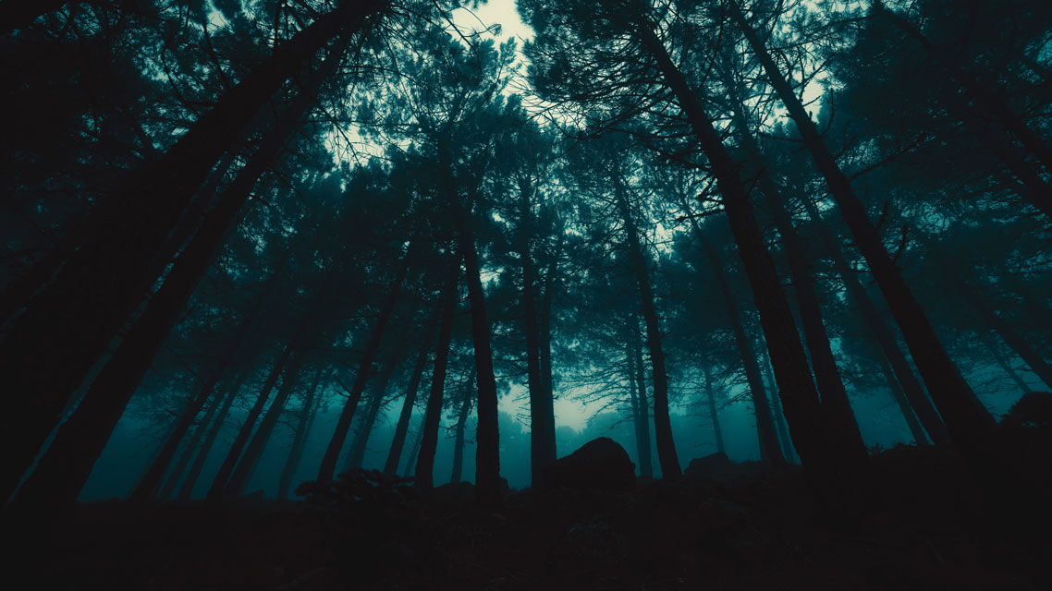

Celebrations

How and why we celebrate.

This term we will look at familiar celebrations and how we celebrate them. We will also look at how people from different cultures and communities celebrate.

-We can demonstrate our understanding of different celebrations.

-We can talk about how we celebrate.

-We can talk about how others celebrate.

-We can compare different

celebrations and look at

similarities and differences.

-We know that some people

celebrate in different ways

and can talk about these

celebrations.

Changing Seasons

and Darkness

-We can talk about seasonal change.

-We can talk about our environment during different seasons.

-We can share how we feel about the darkness using emotion words.

-We can talk about animals that we see in Autumn and Winter.

-We can identify animals that are nocturnal and how to

care for animals.

Nursery Rhyme Week

-We can sing familiar rhymes.

-We can identify rhyme in

spoken language.

-We can finish off a rhyme.

-We can find rhyming pairs.

-We can create a rhyming string.

-We can develop our

own Nursery Rhymes.

Into the Dark…